MultiFEBE

Tutorial 10: harmonic analysis of an arch dam. Fixed base model

J.C. Galván and L.A. Padrón

March 2023

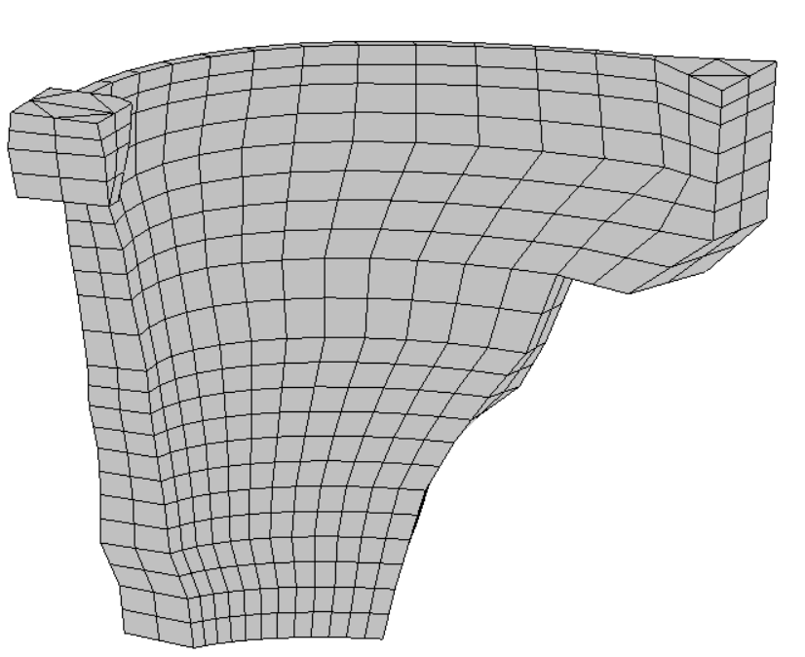  (a) | 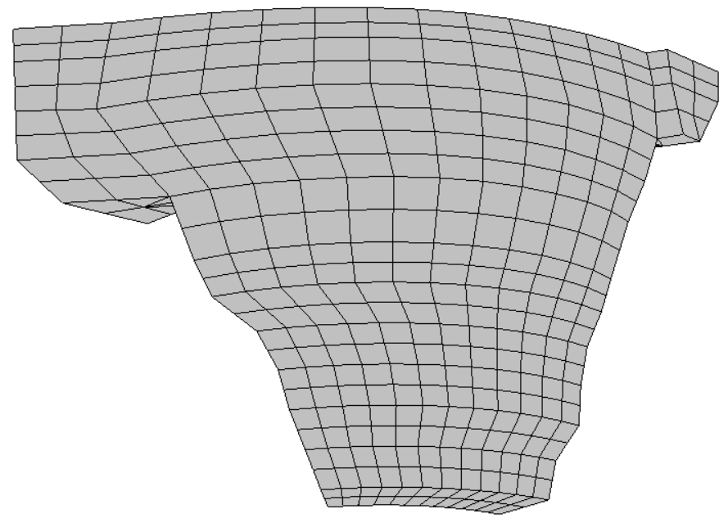  (b)
Figure 1: 3D mesh used for the BEM analysis of the dam wall. (a) Downstream side view. (b) Upstream side view

1 Problem description

In this tenth tutorial, a harmonic analysis of an arch dam is performed using the Boundary Element Method (BEM). Figure 1 shows the boundary element mesh used for the fixed-base model analysis. The model was subjected to a unit harmonic horizontal displacement along the upstream direction at the foundation and abutments of the dam wall (Fig. 2.a) in order to calculate the frequency response function (FRF) at a node located at the midpoint of the dam crest (Fig. 2.b).
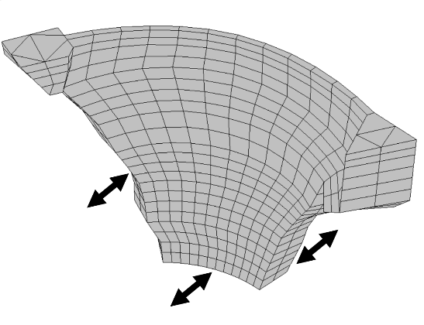  (a) | Study node  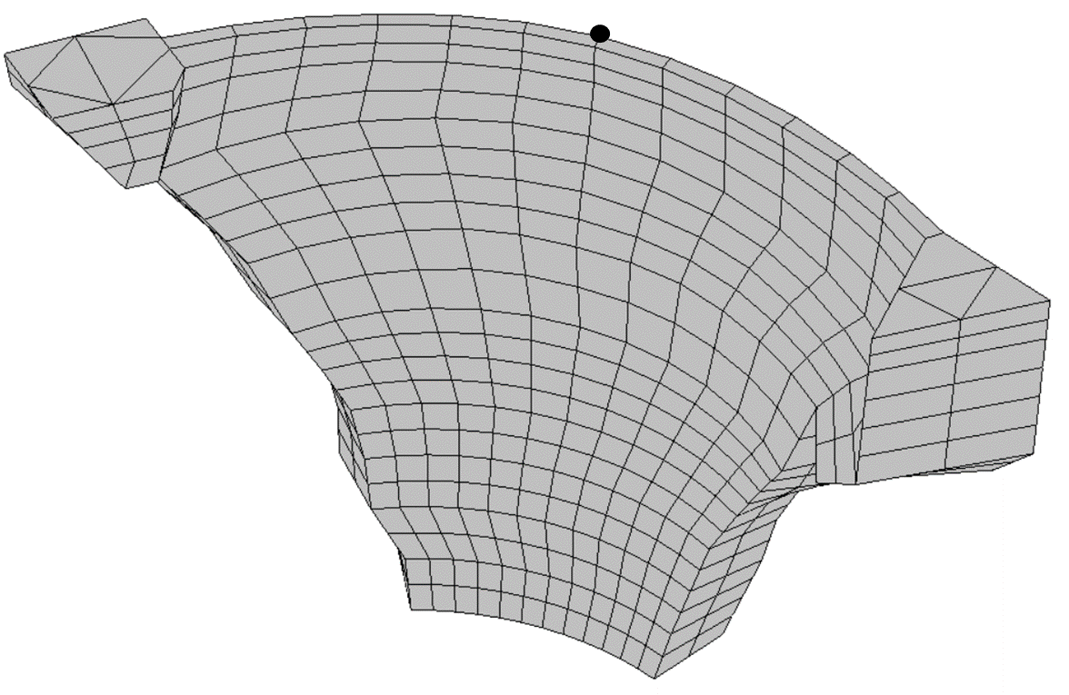  (b)
Figure 2: (a) Excitation along the upstream direction at the foundation and abutments of the dam wall. (b) Study node

The concrete dam wall material is assumed to be viscoelastic with the properties shown in Table 1.
Property | Dam concrete
Young’s modulus (elastic modulus), E (MPa) | 19599.92
Mass density, ρ (kg/m3) | 2300
Poisson’s ratio, υ | 0.2
Internal damping ratio, ξ | 0.01
Table 1: Material properties
2. Pre-processing

In this case, and differently from the previous tutorials, the mesh is generated from the GiD program.

2.1 Mesh generation with GiD

GiD is a pre and post processor for numerical simulations. This software allows to create geometries going from the most basic elements (points) to the highest order elements (volumes) and to define parameters to use later in the MultiFEBE script.

The geometry of the dam wall was constructed according to the information gathered from a specific study made in 1991 [1]. The dam wall geometric representation is composed of three types of entities, namely points, lines and surfaces. A grouping of entities is a layer and each layer corresponds to a dam wall contour. In this problem, six layers (or boundaires) are defined, one per contour (Fig. 3, layer name in red box).
Crest  Downstream_face  Right_abutment  Left_abutment  (a) | Upstream_face  Foundation  (b)
Figure 3: Dam wall layers (or boundaires)

The starting point of the geometric representation is the point. Each point of the geometry has been specified by its coordinates (x y z) and plotted with the option ”Point”. Then, every straight line of the model is created with the option ”Line” with its initial and final points. It should be noted that wall curved lines have been created from a set of points which have been joined by lines and converted to a curved line using the option “Collapse->lines”. Then, the surfaces are created. To do it, each surface there must be a set of lines that define a closed contour. To create a surface, the first step is to select the option “Geometry->Create->NURBS Surface->By Contour” and then select the lines that close the contour; finally pressing ESC the selection is concluded.

Once the surfaces have been created, the mesh will be generated. The BE mesh consists of nine-node quadratic quadrilateral elements and six-node quadratic triangular elements (Fig. 4). So, to generate the mesh, firstly it is chosen “Meshing->Quadratic elements->Quadratic9”, secondly, “Meshing->Structured->Surfaces”, and finally, select the surface to mesh.

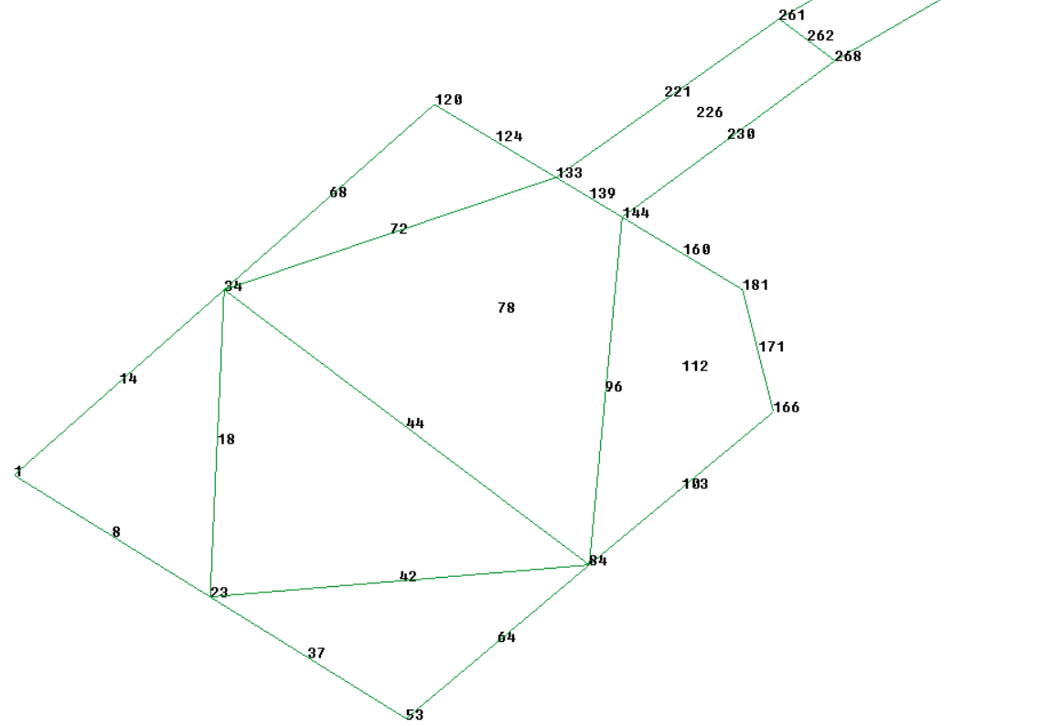
Figure 4: Part of the dam wall crest mesh. Nine-node quadratic quadrilateral elements and six-node quadratic triangular elements can be seen

It is worth noting that the nodes common to two or three contours will be duplicated and they will have different numbering (Fig. 5).

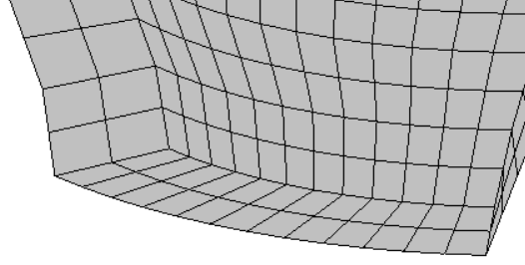
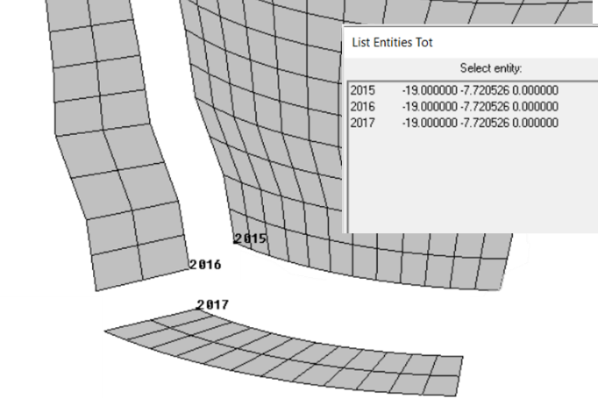  (a) | 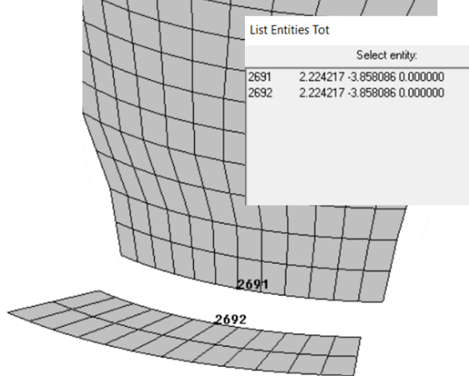  (b)
Figure 5: Example of duplication of nodes.
(a) Node belonging to three contours. (b) Node belonging to two contours
Once the mesh is generated, it is written in GiD native MultiFEBE format using the implemented template file *.bas shown in the MultiFEBE Reference Manual (Appendix C). It is a simple plain text file containing a script in GiD languaje. Two versions of the template file are included in the package, one with carriage return of the Windows type (multifebe_win.bas) and another with the Unix type (multifebe_unix.bas).

Finally, the file generated contains nodes, elements and parts of the mesh which, in this example, will be copied and pasted in the input data file.

  - Input data file

The first part to configurate is the problem definition in the section [problem]. This example is a 3D harmonic mechanical problem.

[problem]
n = 3D
type = mechanics
analysis = harmonic

Then, a list of frequencies is generated by specifying the number of frequencies. It has been defined an analysis of 115 frequencies, from 0.01 Hz to 6.7 Hz.

[frequencies]
Hz
list
115
0.01
0.1
0.2
.
.
.
6.7
6.8
6.9

As mentioned, the mesh is going to be read from the same input file, so sections [nodes], [elements] and [parts] must be written in the script.
[nodes]
3228
1 -8.884500000000000e+01 -4.216000000000000e+01 1.200000000000000e+02
2 -8.884500000000000e+01 -4.216000000000000e+01 1.200000000000000e+02
.
.
.
3227 8.813571200000000e+01 -3.769609600000000e+01 8.800000000000000e+01
3228 8.813571200000000e+01 -3.769609600000000e+01 8.800000000000000e+01

[elements]
732
38 tri6 1 3 207 224 118 213 178 164
39 tri6 1 3 195 207 118 201 164 154
.
.
.
731 quad9 1 2 7 40 48 20 19 43 29 12 26 732 quad9 1 2 7 2 33 40 5 15 36 19 16

[parts]
6
1 Downstream_face
2 Upstream_face
3 Left_abutment
4 Right_abutment
5 Foundation
6 Crest

In the section [export], several export and notation settings are defined. In this example, the nodal solutions will be exported. The complex notation is set as cartesian and the results for specific nodes are taking by specifying the number of nodes (1) and the identifiers of the nodes (835).

[export]
complex_notation = cartesian
nso_nodes = 1 835

As the problem has just one material, the section [materials] will need two lines: a first line for the number of materials in the model and a second line for the properties such as tag, type, E, ρ, ν and ξ.

[materials]
1
1 elastic_solid E 19599921600. rho 2300. nu 0.2 xi 0.01

In the next section [boundaries], it is necessary to specify the number of boundaries in the first line, and a line per boundary by indicating the boundary identifier, the identifier of the part that discretize it, and finally the boundary class. In this example there are 6 boundaries: boundary 1 is the part 1 of the mesh, boundary 2 the part 2, boundary 3 the part 3, boundary 4 the part 4, boundary 5 the part 5 and boundary 6 the part 6 and all of them are ordinary boundaries.

[boundaries]
6
1 1 ordinary
2 2 ordinary
3 3 ordinary
4 4 ordinary
5 5 ordinary
6 6 ordinary
In the section [bem formulation over boundaries], the user can modify the BEM formulation, i.e. the type of Boundary Integral Equations (BIEs) to be used when building the BEM equations and the collocation strategy to be used. The nodal collocation (sbie), collocation at the boundary element nodes, is the ideal since it leads to the best conditioning of the system. By another hand, non-nodal collocation is also possible (sbie_boundary_mca), but it should be used only where nodal collocation turns problematic. The non-nodal collocation strategy implemented here is the so-called Multiple Collocation Approach (mca). In this example with six boundaries, the collocation strategy in all boundaries must be nodal, with the exception of boundary 5, where a non-nodal collocation strategy is prefered for all the nodes along its boundaries, with a displacement towards inside each element of 10% the width of the element. In this case, one should write:

[bem formulation over boundaries]
boundary 1: sbie
boundary 2: sbie
boundary 3: sbie
boundary 4: sbie
boundary 5: sbie_boundary_mca 0.01
boundary 6: sbie

The format of the [regions] section consists of a first line indicating the number of regions, 1 in this case. For each region there must be a block of data consisting of several lines of data. The second one is the region identifier and the region class (1 be). As the region is a BE region, the third line indicates the number of boundaries and a list of boundaries, with their orientation signs (6 1 2 3 4 5 6). The fourth line defines the material. The fifth line defines the number and a list of BE body loads (0) and the sixth line defines the number and a list of incident fields (0), beeing the format of the section:

[regions]
1
1 be
6 1 2 3 4 5 6
material 1
0
0

Now, in the section [conditions over be boundaries] all boundary conditions will be specify in global coordinates because they are planar and their normal vectors are parallel to one of the global axes. As a 3D problem, there are three lines for every boundary: a first line for the ”x” direction, the second one for the ”y” direction and the third one for the ”z”, where the first number of every line indicates the type of condition (here 0 for displacement and 1 for traction) and the second one its value in complex number because it is a harmonic analysis. In this case, a unit harmonic horizontal displacement along the upstream direction (”y” direction) was given at the foundation and abutments of the arch dam.

[conditions over be boundaries]
boundary 3: 0 (0.,0.)
0 (1.,0.)
0 (0.,0.)
boundary 4: 0 (0.,0.)
0 (1.,0.)
0 (0.,0.)
boundary 5: 0 (0.,0.)
0 (1.,0.)
0 (0.,0.)

- Results and discusión

3.1 Nodal solutions file (*.nso)

The FRFs of the study node computed with the harmonic analysis using two different software (Aznárez et al. [2] and MultiFEBE) are plotted in figure 6. As mentioned, the system excitation is defined as a harmonic uniform unitary displacement field along the foundation and abutments in upstream direction (Fig. 2 (a)).

Firstly, in figure 6 it can be seen a very good agreement between the softwares employed. It can be also observed two peaks clearly captured at 5.00 and 6.44 Hz, approximately, which correspond to the dam wall second and third natural frequencies, respectively, under upstream excitation direction (Galván et al. [3]).

Figure 6: FRFs. Transversal response of the midpoint of the dam crest

By other hand, figure 7 shows the real (a) and imaginary (b) parts of the FRFs of the study node where it can be also observed a very good agreement between the softwares employed.
(a) | (b)
Figure 7: Real (a) and imaginary (b) parts of the FRFs of the study node

3.2 Gmsh results file (*.pos)

In this section, the dam wall second and third mode shapes of vibration (Galván et al. [3]) will be plotted using the Gmsh software with the output file obtained from MultiFEBE code. To do that, the section [export] of input data file of the MultiFEBE software must take the form:

[export]
complex_notation = cartesian
export_pos = T

where “export_pos” exports results in Gmsh MSH file format 2.2. It should be noted that the frequencies corresponding to the mode shapes are obtained from the maximum peaks of the imaginary part of FRF (Fig. 7.b).

Once the output file (*.pos) is obtained, named “SECOND_MODE_5.01Hz” for the second mode shape of the current example, it is opened from Gmsh software following the steps shown in figure 8 appearing the dam wall mesh (Fig. 9.a). In figure 9.a can be seen in “Post-processing” module, marked by a red box, that nodal displacements and tractions are activated. Due to the fact that the goal of this section is to plot the dam wall second and third mode shapes, nodal traction must be deactivated (Fig. 9.b).

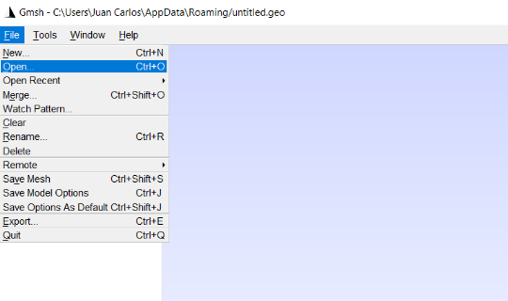  (a) | 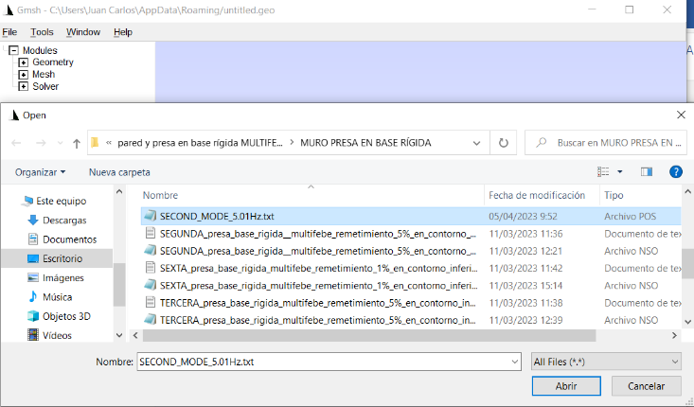  (b)
Figure 8: (a) File -> Open. (b) Select the *.pos file in the corresponding folder

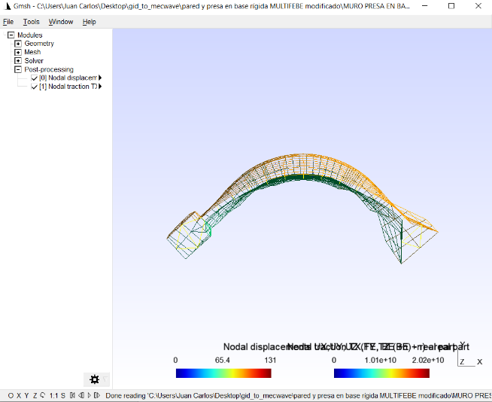  (a) | 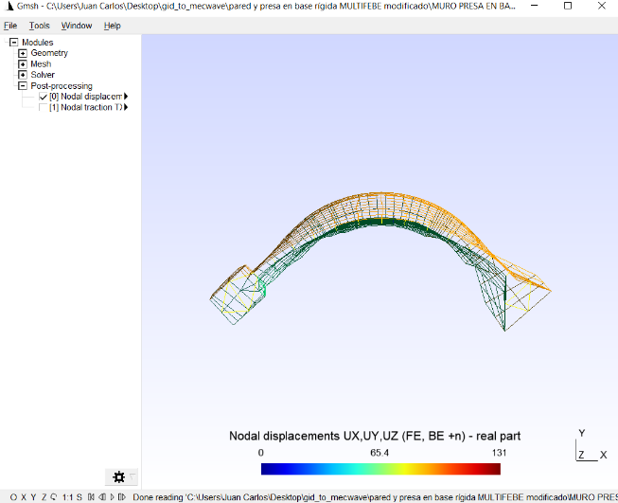  (b)
Figure 9: Dam wall mesh. (a) Nodal displacement and traction activated. (b) Nodal traction deactivated

Next, the second mode shape is obtained following the steps showed in figure 10.

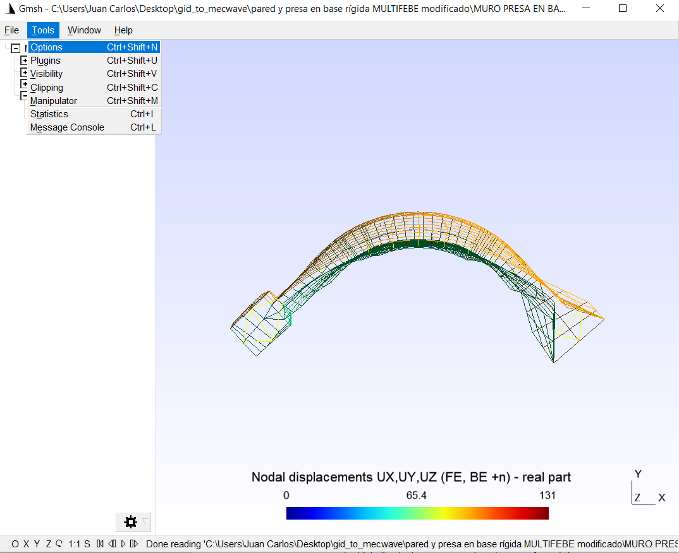  Step 1: Select Tools -> Options | 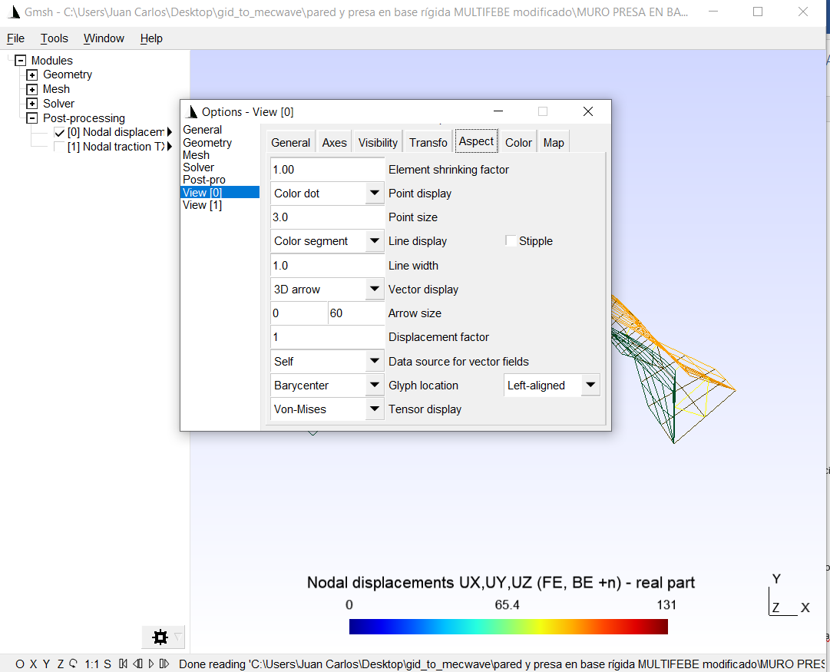  Step 2: Select View[0] and “Aspect”
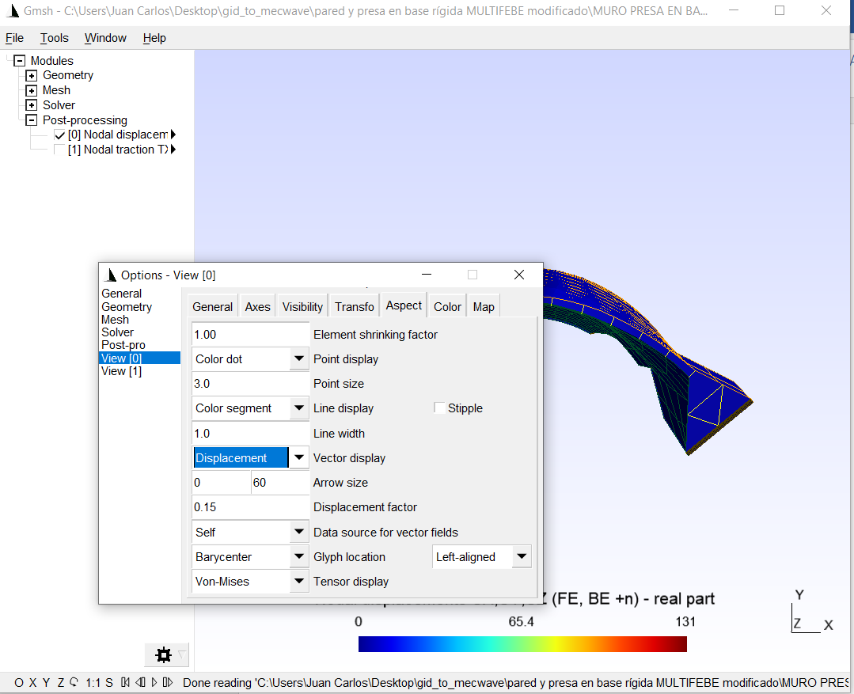  Step 3: Select in “Vector display” the “Displacement” option. The displacement scale factor can be modified in “Displacement factor” (0.15 in this example) | 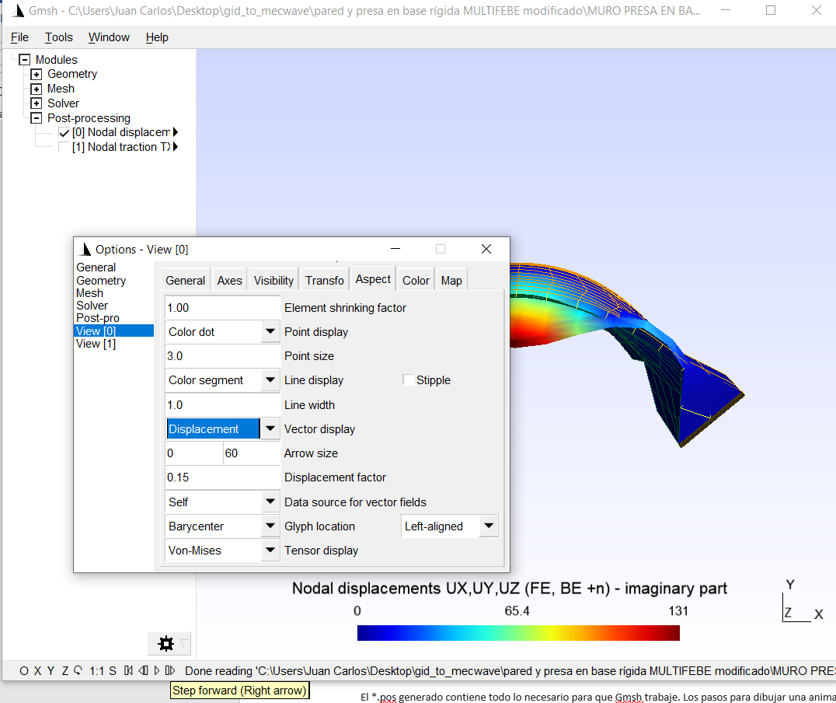  Step 4: Changing “real part” to “imaginary part”, the first mode shape is obtained
Figure 10: Steps to obtain the mode shape of vibration from Gmsh software
Figure 11 shows different views of the second mode shape.
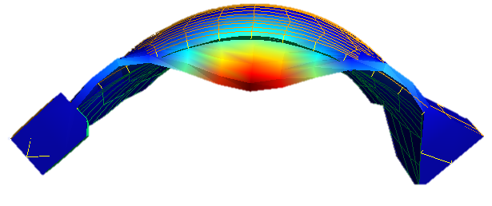
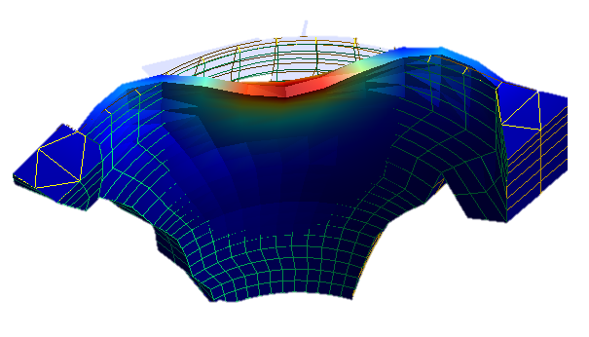
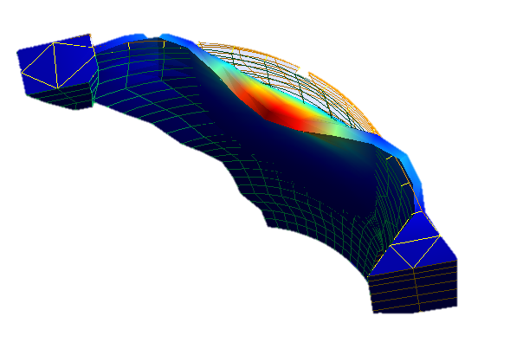
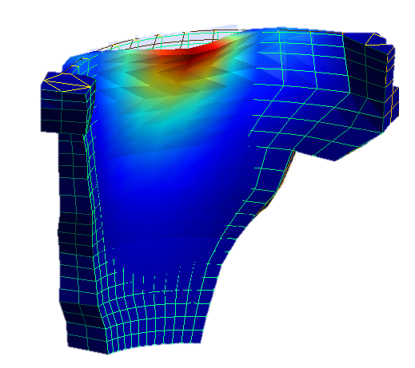
Figure 11: Views of the second mode shape of vibration

In the same way, the third mode shape is obtained. Next, the second and third mode shapes will be compared with the ones showed in Galván et al. [3] which have been plotted with GiD software using the output file obtained with Aznárez et al. code [2]. The first two symmetrical mode shapes obtained with the two softwares are shown in figure 12 where a very good agreement is observed between them.

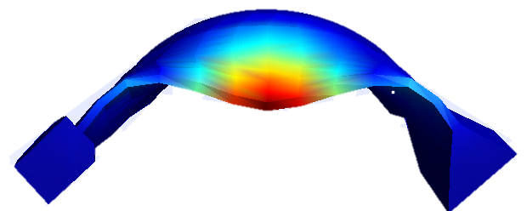 | 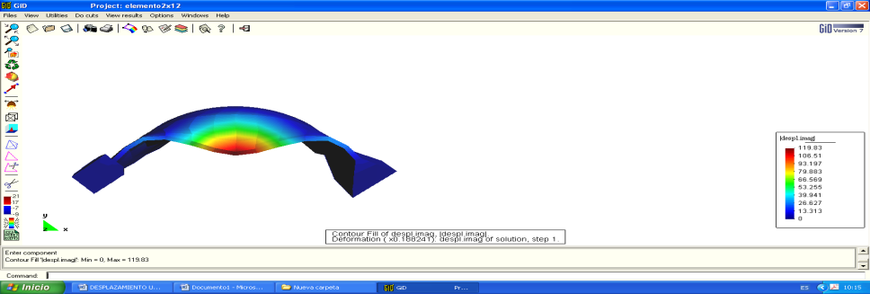
Second mode shape
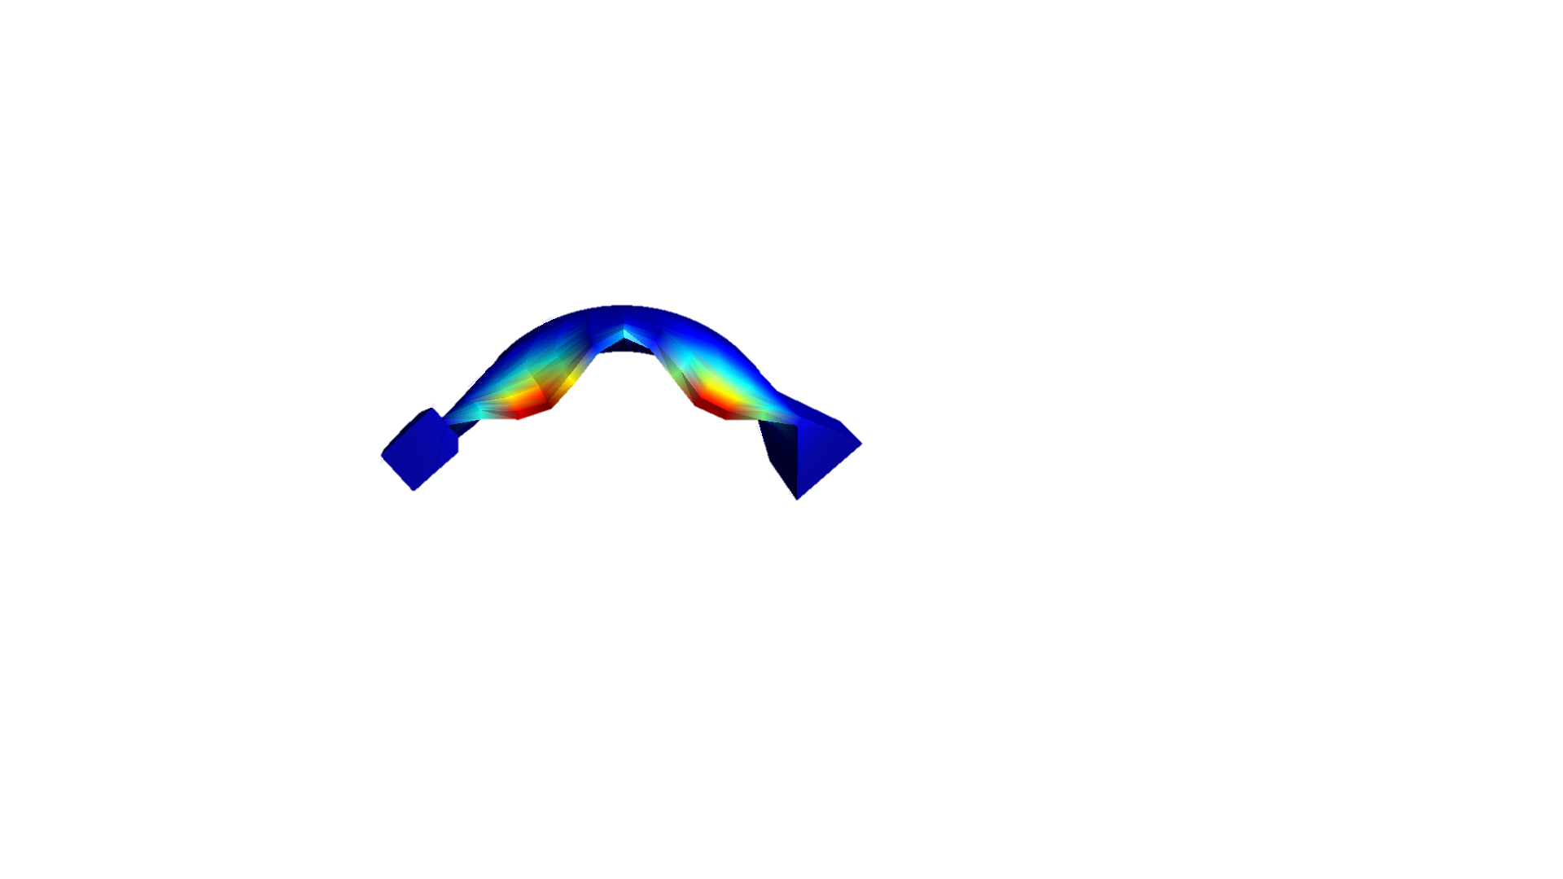 | 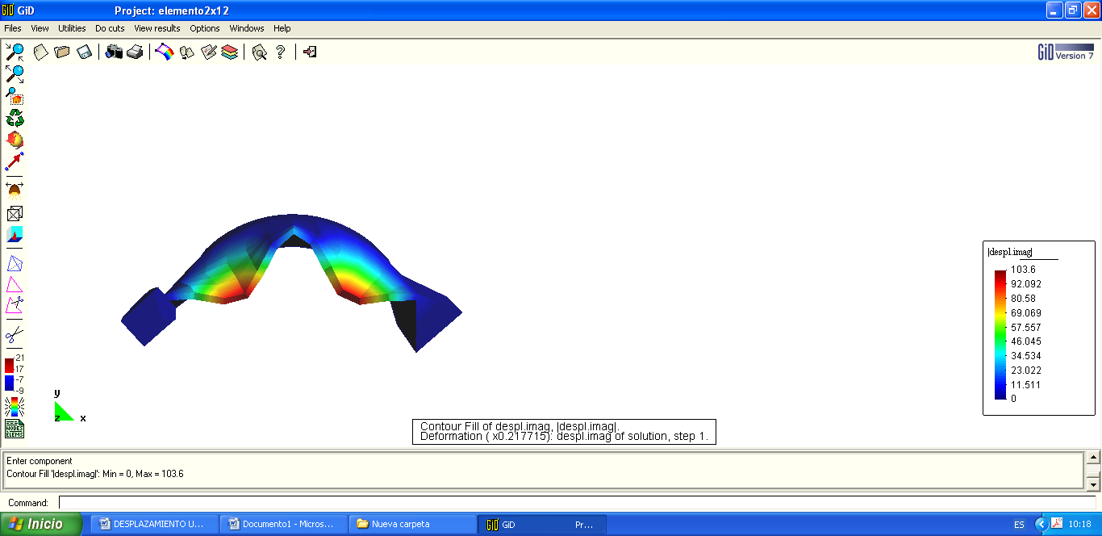
Third mode shape
Figure 12: Second and third mode shapes of vibration. MultiFEFE code (left column); Aznárez et al. code [2] (right column)
ç
References

[1] Documento XYZT. Presa de Soria. Dirección General de Obras Hidráulicas. Ministerio de Obras Públicas y Transportes; 1991

[2] J. J. Aznárez, O. Maeso, and J. Domínguez. BE analysis of bottom sediments in dynamic fluid-structure interaction problems. Engineering Analysis with Boundary Elements, 2006, 30:124–136

[3] J. Galván, L. Padrón, J. Aznárez, O. Maeso, Boundary element model for the analysis of the dynamic response of the Soria arch dam and experimental validation from ambient vibration tests. Engineering Analysis with Boundary Elements, 2022, 144: 67–80

